**Connection Diagram and Table: (Rev4)**

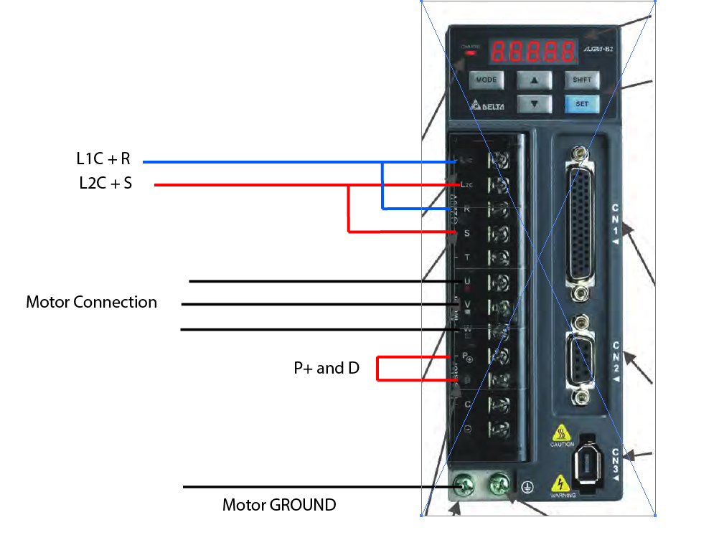

**CN1:**

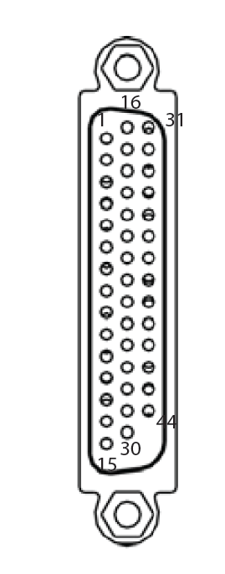

Need to connect for prototyping (Please refer to Manual **3.7.1 Position (PT) Control Mode)**

|  |  |  |
| --- | --- | --- |
|  | Pin | MEGA PIN |
| /SIGN | 37 | GND |
| SIGN | 39 | Motor 1 (2) Motor 2 (4) Motor 3 (6) Motor 4 (8) |
| /PULSE | 41 | GND |
| PULSE | 43 | Motor 1 (3) Motor 2 (5) Motor 3 (7) Motor 4 (9) |
| VDD to COM+ | 17-11 |  |
| DI 1 (SON) | 9 | Motor 1 (14) Motor 2 (15) Motor 3 (16) Motor 4 (17) |
| DI 5 (ALARM RESET) | 33 | Motor 1 (50) Motor 2 (51) Motor 3 (52) Motor 4 (53) |
| DI6 | 32 | GND |
| DI7 | 31 | GND |
| DI8 | 30 | GND |
| COM- | 14 | GND |
| OA | 21 | Motor 1 (22) Motor 2 (25) Motor 3 (28) Motor 4 (31) |
| /OA | 22 | GND |
| OB | 25 | Motor 1 (23) Motor 2 (26) Motor 3 (29) Motor 4 (32) |
| /OB | 23 | GND |
| OZ (NOT USED, RESERVED) | 13 | Motor 1 (24) Motor 2 (27) Motor 3 (30) Motor 4 (33) |
| /OZ (NOT USED, RESERVED) | 24 | GND |
| DO 1 |  | Motor 1 (34) Motor 2 (35) Motor 3 (36) Motor 4 (37) |
| DO 2 |  | Motor 1 (38) Motor 2 (39) Motor 3 (40) Motor 4 (41) |
| DO 4 |  | Motor 1 (42) Motor 2 (43) Motor 3 (44) Motor 4 (45) |
| DO 5 |  | Motor 1 (46) Motor 2 (47) Motor 3 (48) Motor 4 (49) |

IR SENSOR

|  |  |  |
| --- | --- | --- |
| Input |  | Motor 1 (A0) Motor 2 (A1) Motor 3 (A2) Motor 4 (A3) |
| GND |  | GNDs |

To Serial

|  |  |  |
| --- | --- | --- |
| TX (RJ45) |  | RX1 (17) |
| RX (RJ45) |  | TX1 (18) |

Servo Setup Step

|  |  |  |  |
| --- | --- | --- | --- |
| Step |  |  |  |
| 1 | Reset Parameter to Default | P2-08 | 10 |
| 2 | Encoder Pulse Val (Higher more frequent but may lose step) | P1-46 | 100 |
| 3 | Gear Ratio Numerator | P1-44 | 50000 |
| 4 | Gear Ratio Denominator | P1-45 | 100 |
|  |  |  |  |

Ensure:

|  |  |  |  |
| --- | --- | --- | --- |
| Position Mode |  | P1-00 | 0002 |
|  |  |  |  |